21.10.2019

Furkan Tokgöz

**Series Interleaving FFT Results**

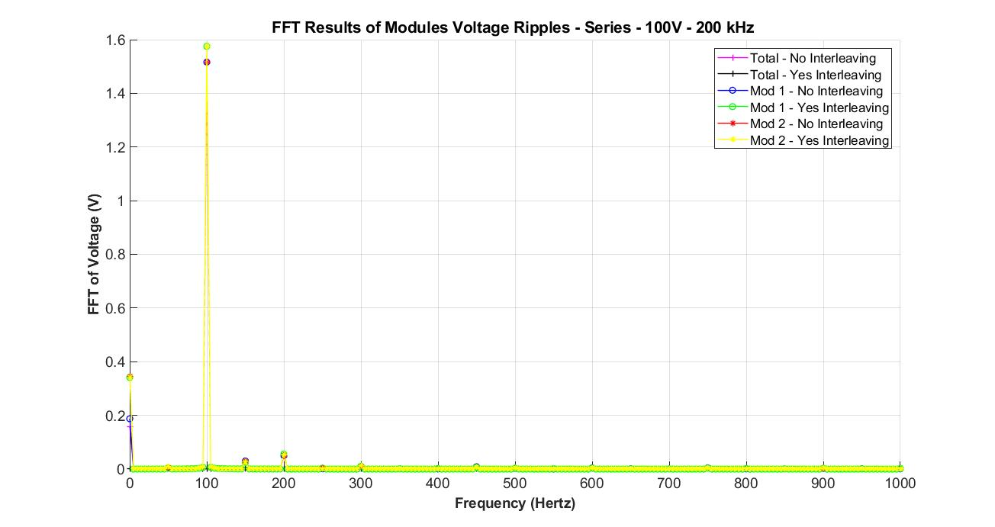I have included all FFT results of series configuration. Below, you can see the FFT result of total voltage, voltages of module 1 and 2. As can be seen, 100 Hz component is very high compared to the rest of the low frequency range. However, in total DC link voltage, there is no harmonic content at this frequency. The other harmonics are very small in magnitude. So, concluding a result may not be very accurate with this calculation.

At higher frequencies, we can easily see that interleaving decreased switching harmonics. So, Since, we did not record the DC link current waveform, it is not very clear that whether interleaving works as desired at these frequencies.

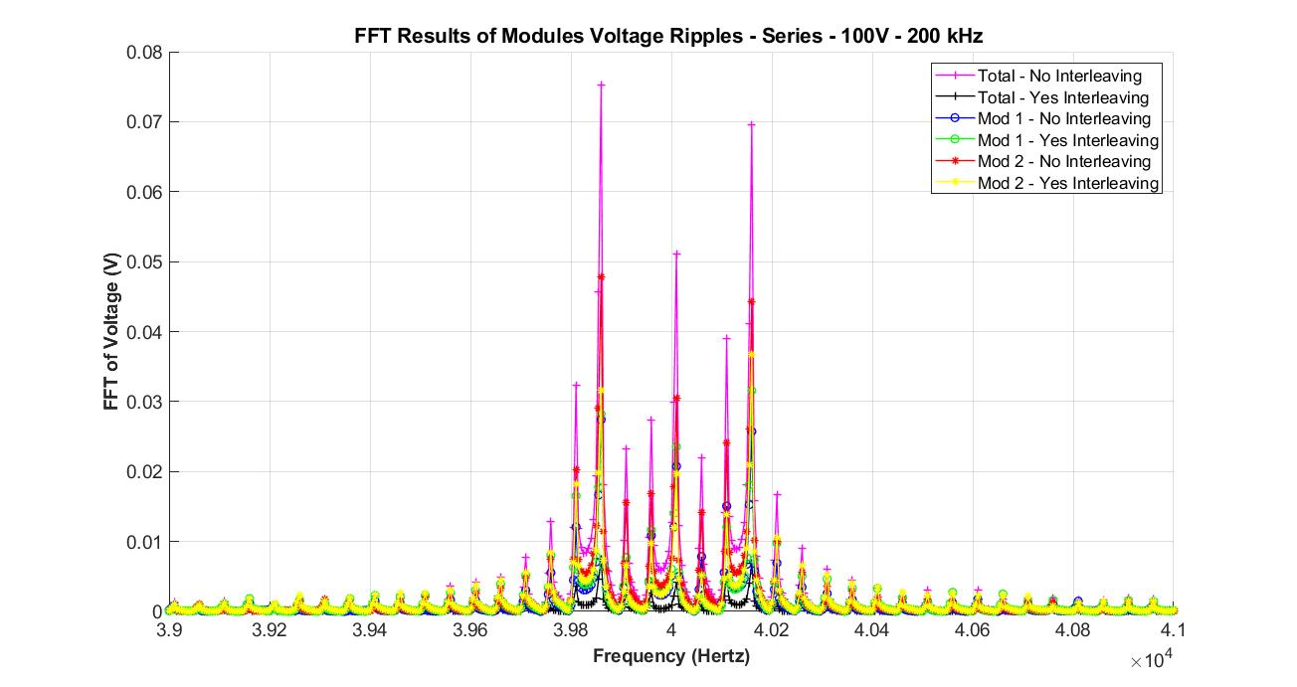

Finally, whole frequency range FFT result can be seen below.

